# Exercises: WordPress Plugins

Problems for exercises and homework for the [“WordPress Basics” course @ SoftUni](https://softuni.bg/courses/wordpress-basics).

In this homework, you are supposed to build an **online shop** based on **WordPress** and **wooCommerce**. This will involve installing and configuring a **WP theme** and installing and configuring a few **WP plugins**, as well as **creating content** in your WordPress online shop.

## What Shall We Build?

Following this step-by-step tutorial, we shall build a **modern e-commerce web site**, shown at the screenshots below:

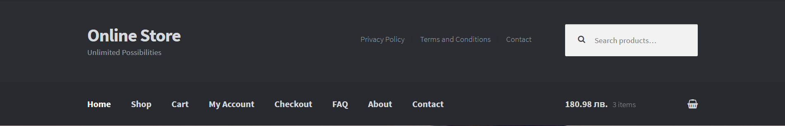  

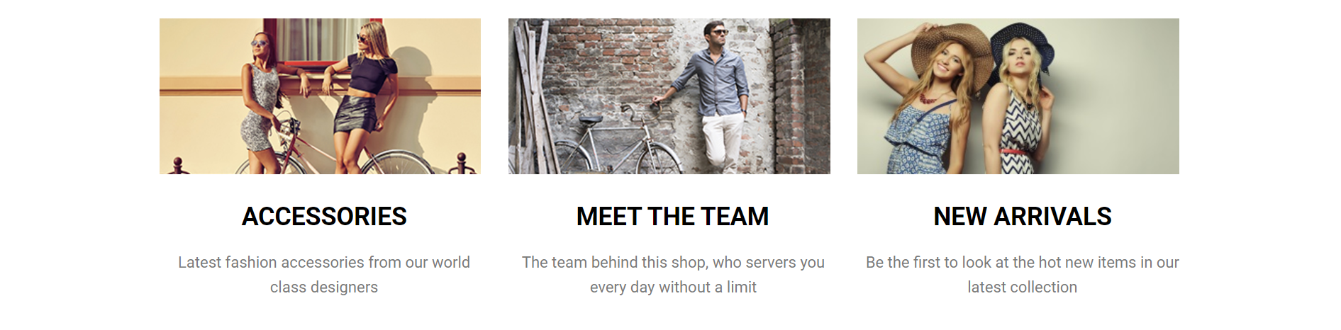

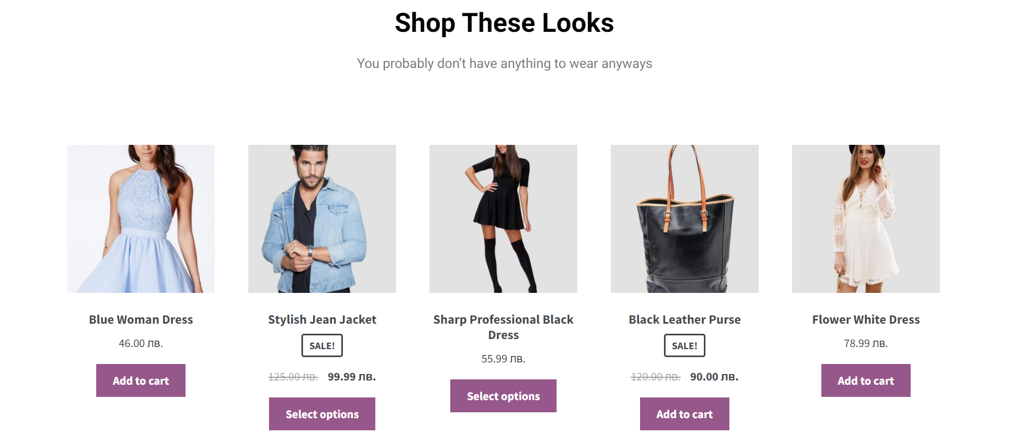

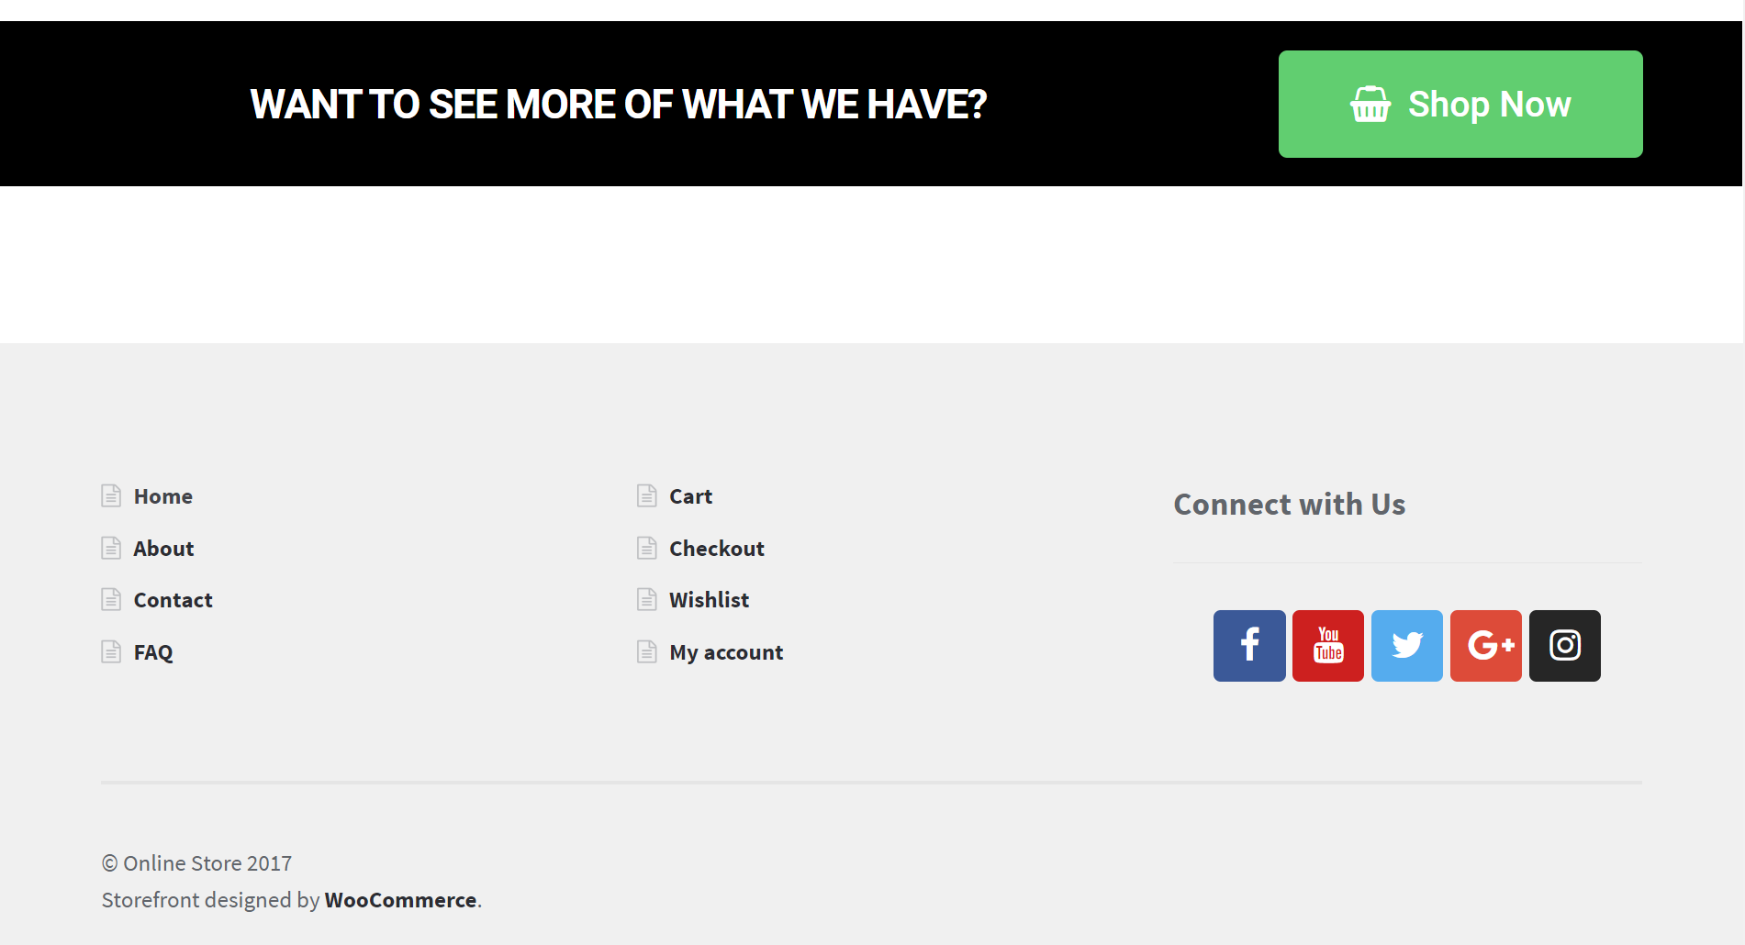

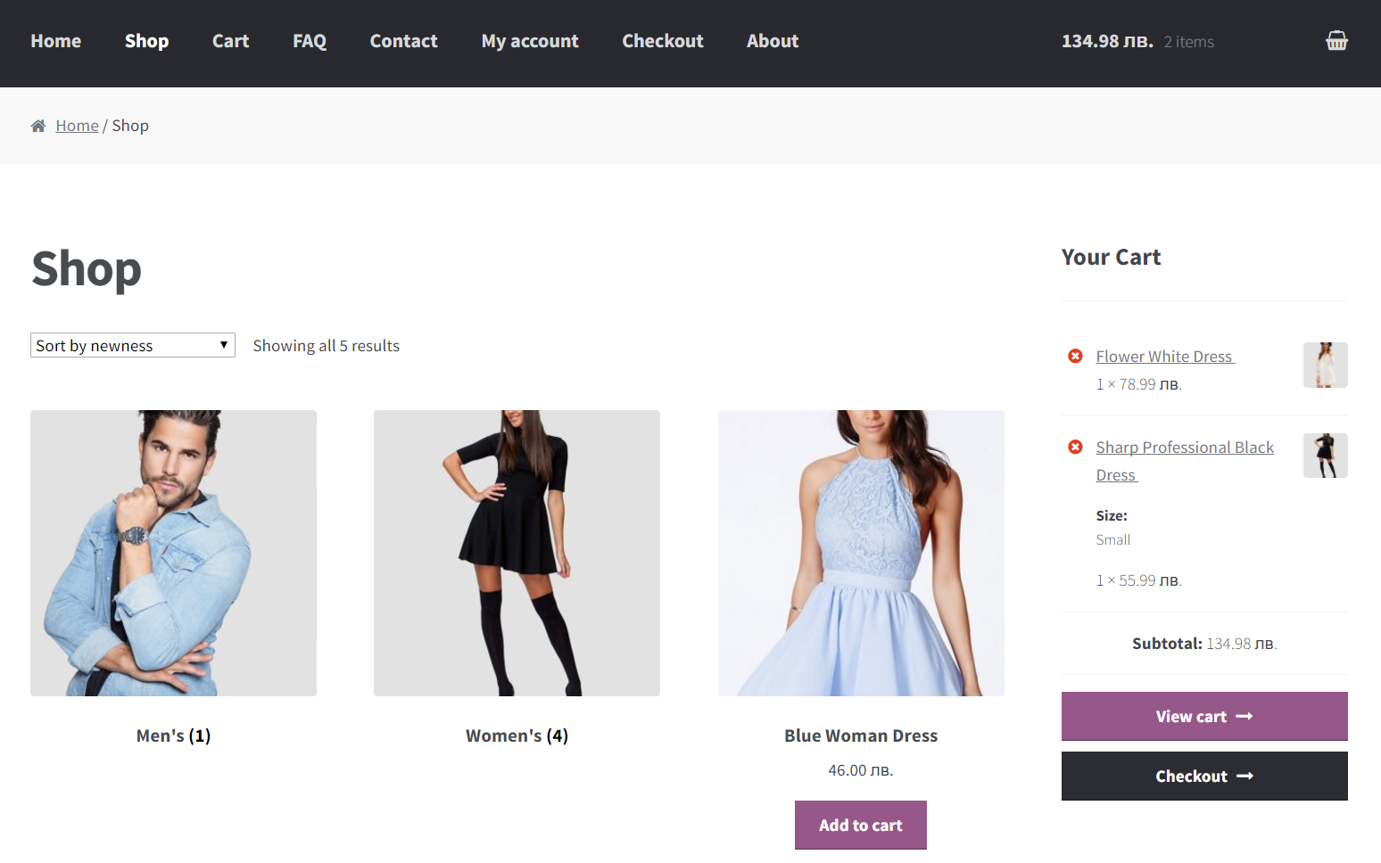

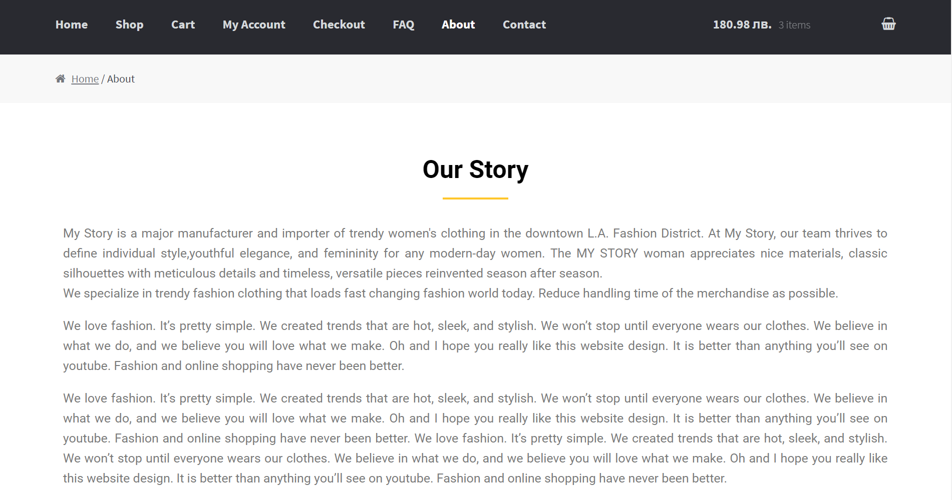



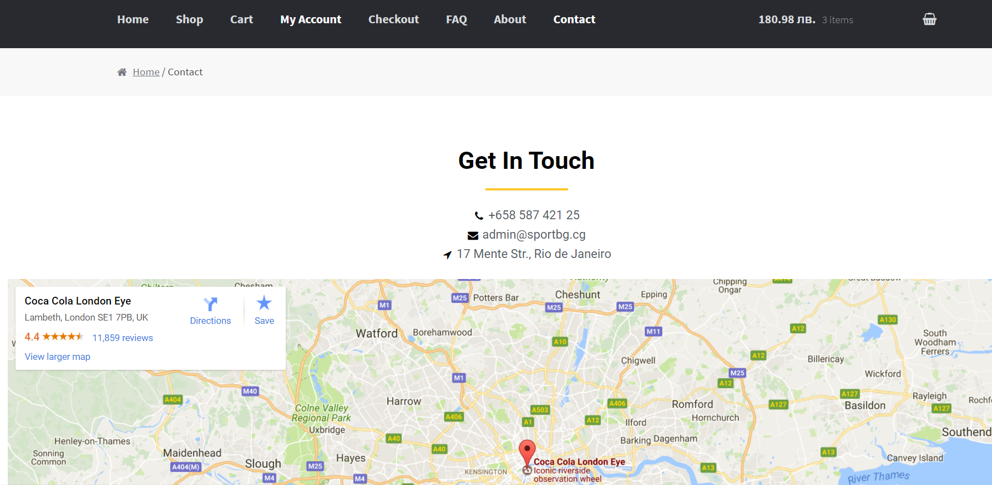

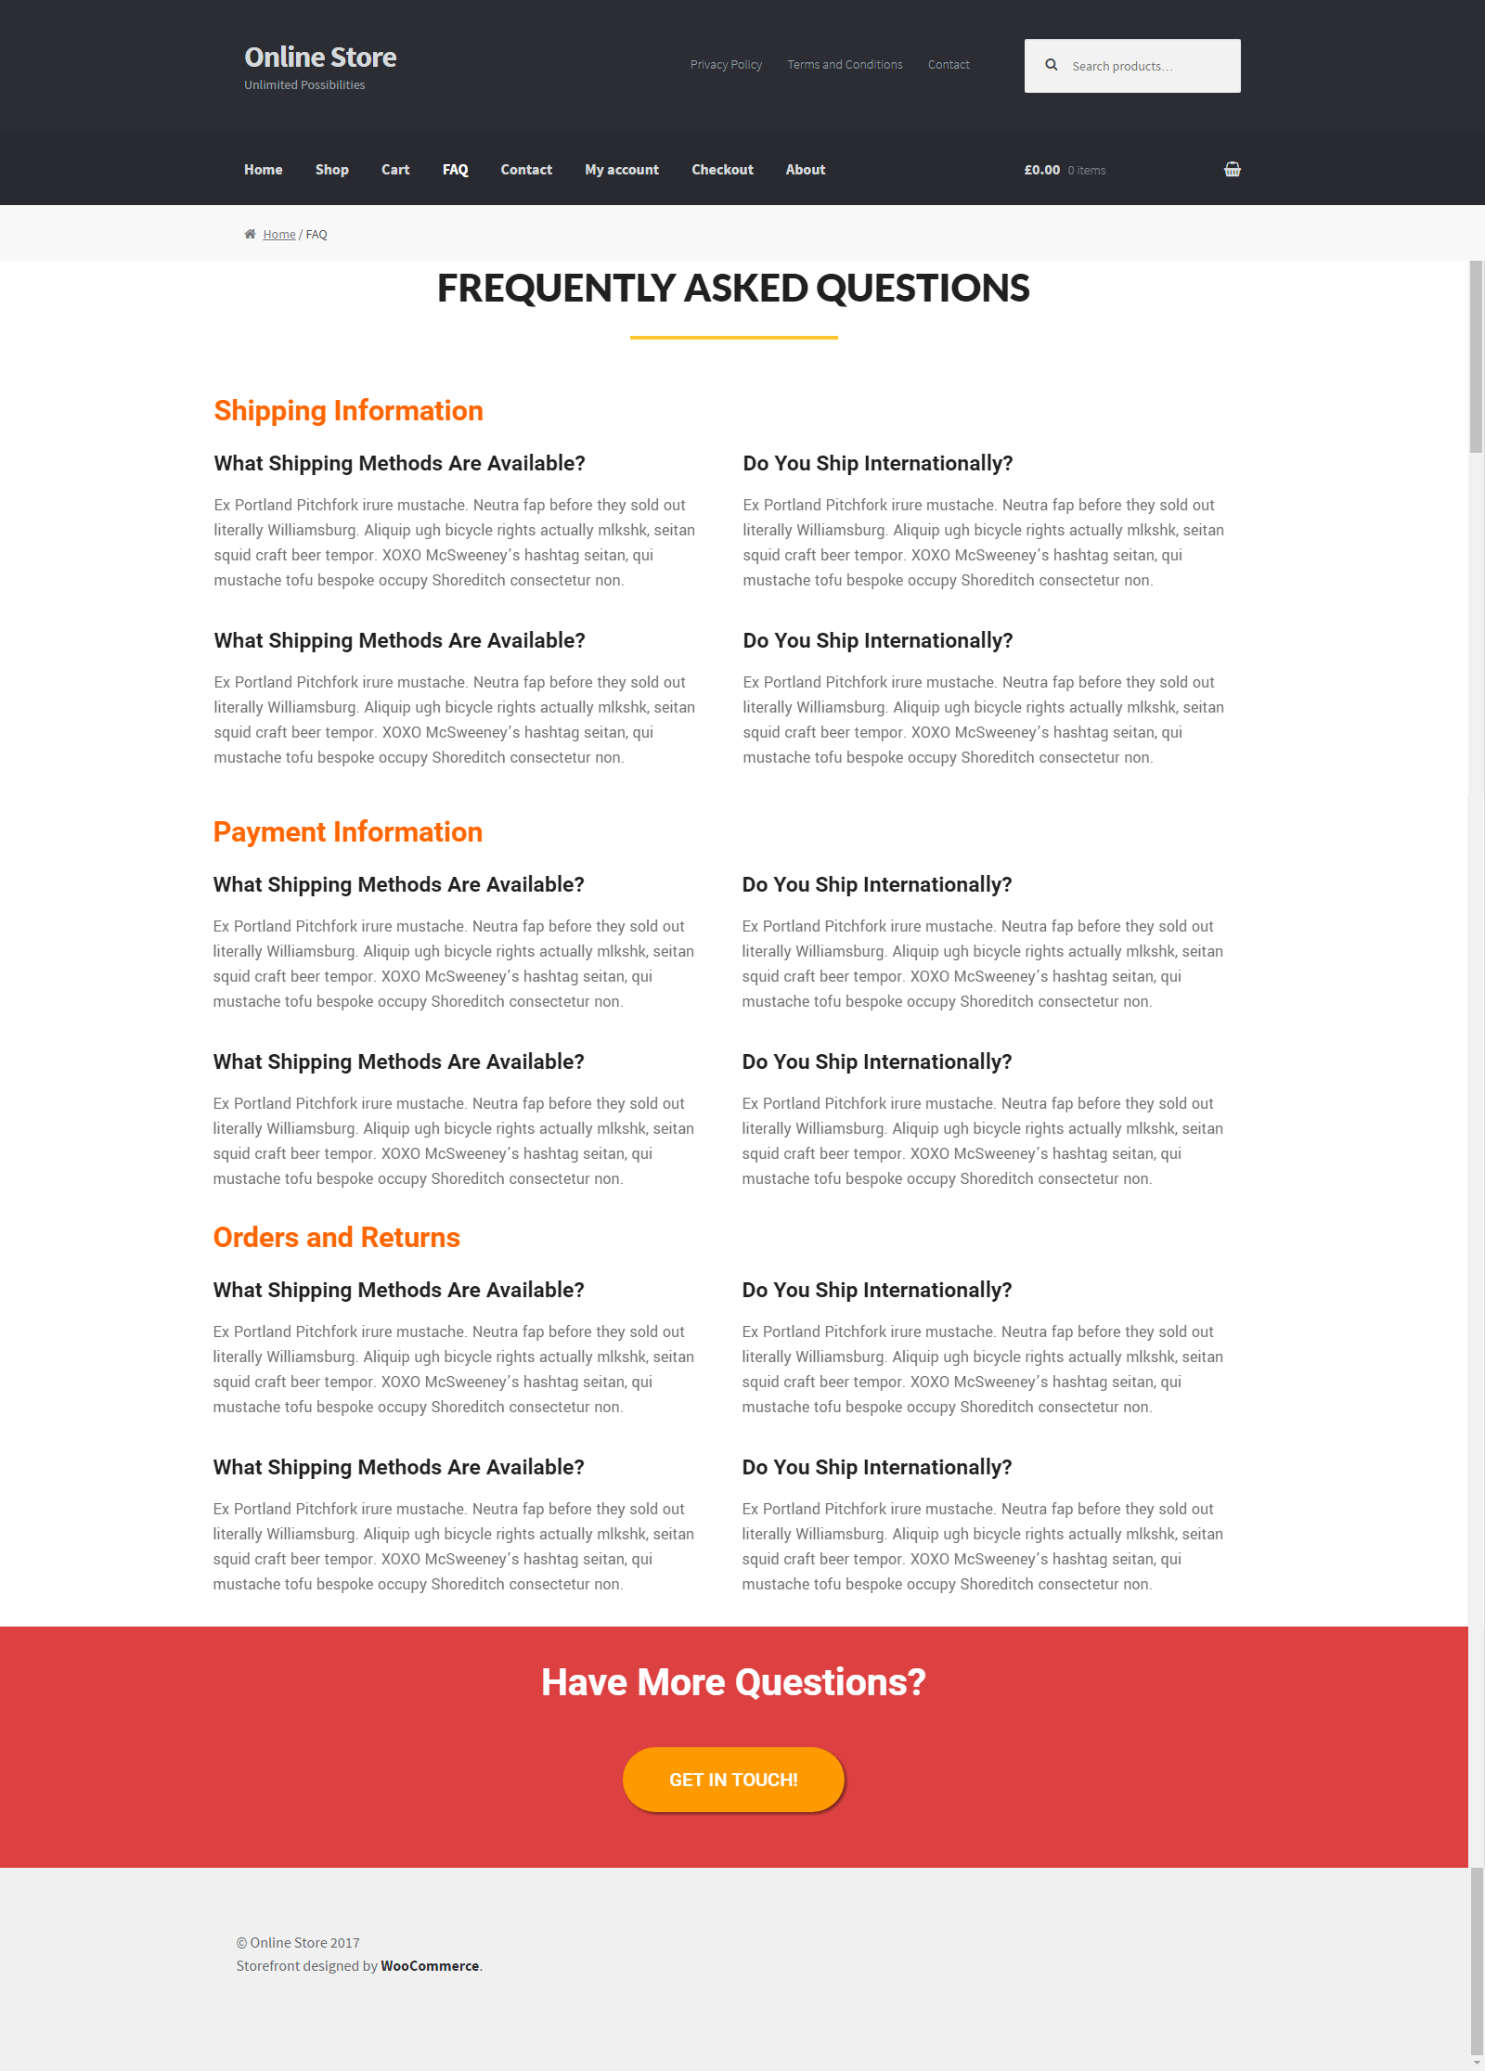

Did you like it? **Let’s start.** You may change the images / texts to match better your business.

### Build Your Own Shop

You are free to **follow exactly the tutorial steps** given in this guide, or **modify** them to match better your interests. For example, you could **build your own shop** with your own products and categories, e.g. a **tea shop** or a **bookstore**. You are free to change the company name / logo / products / categories / images / descriptions / page content / etc.

## Install the "Storefront" Theme

Open your WordPress on your **site** e. g, <http://shopbg.cf/wp-admin>, go to [Appearance] -> [Themes] -> [Add New] theme “**Storefront**”, **install** it and then **activate** it.

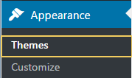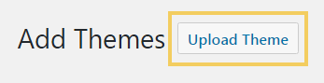

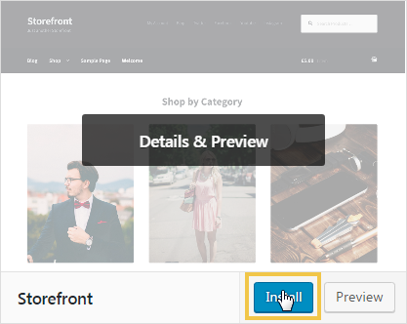 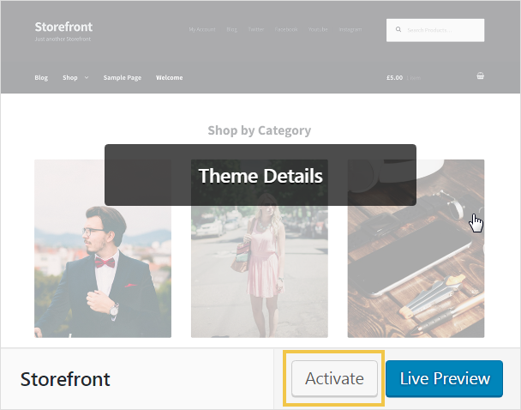

If your Web site hosting environment (or XAMPP installation) is not correctly configured, **your theme might fail to upload**. In most cases the problem comes from misconfigured PHP or incorrect folder permissions. This is how to resolve these problems:

* Increase the **maximal file upload size** from php.ini – <http://stackoverflow.com/questions/2184513/php-change-the-maximum-upload-file-size>
* Change the folder permissions for your wp-content folder – <http://www.wpbeginner.com/beginners-guide/how-to-fix-file-and-folder-permissions-error-in-wordpress/>, <https://codex.wordpress.org/Changing_File_Permissions>

## Install the Recommended Plugins

* **Elementor** – visual editor, that helps us create the layout of our site content (pages, posts, others).
* **Title Toggle for Storefront Theme** – hides titles on a per post / page basis.
* **wooCommerce** – this is the main e-commerce plugin that will allow us to sell products and collect payment.
* **YITH** **WooCommerce** **Wishlist** – this plugin lets us create a wish list page for our shop.
* **Anywhere Elementor** – allows inserting Elementor pages anywhere (e.g. in the sidebars) using short codes.
* **Smar Slider 3** – for creating simple sliders.
* **WP Super Cache** – caching plugin for improved site performance.

### Elementor – Visual Page Builder Plugin

First, install and activate **Elementor**:

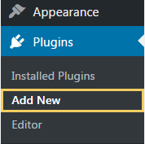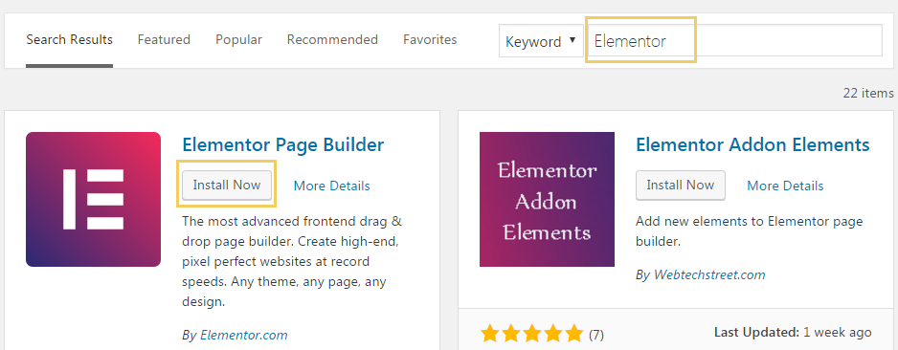

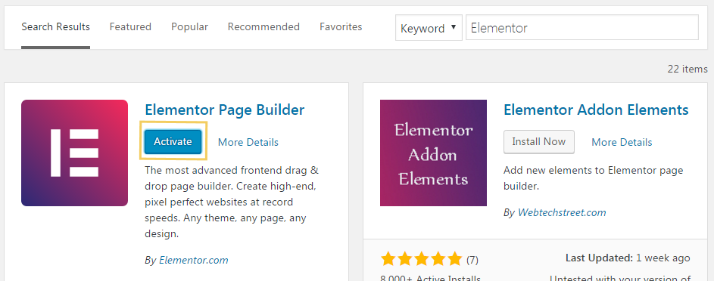

### Title Toggle for Storefront Theme

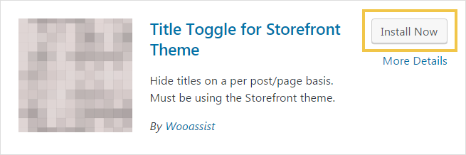

### wooCommerce – E-commerce Solution for WordPress

Install and configure **wooCommerce**:

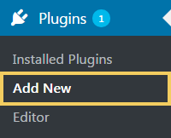 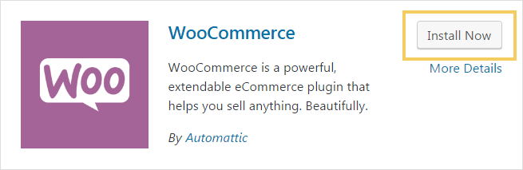

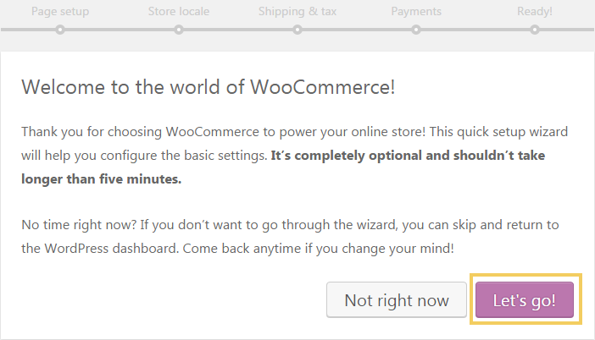

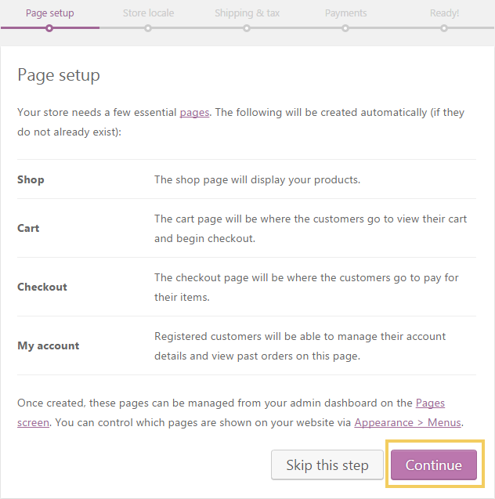 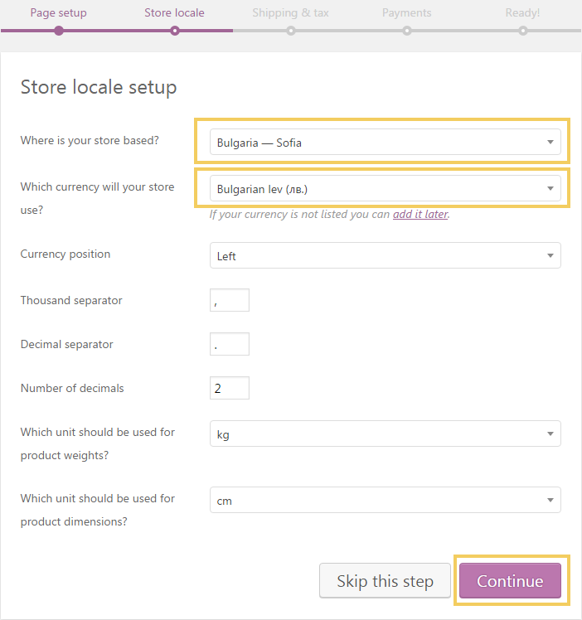

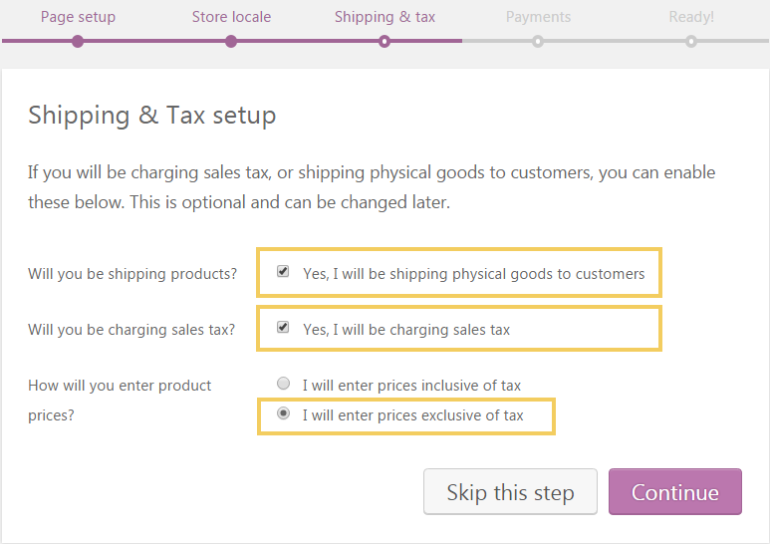

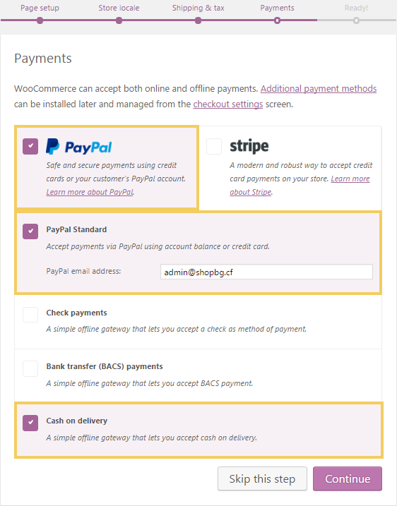 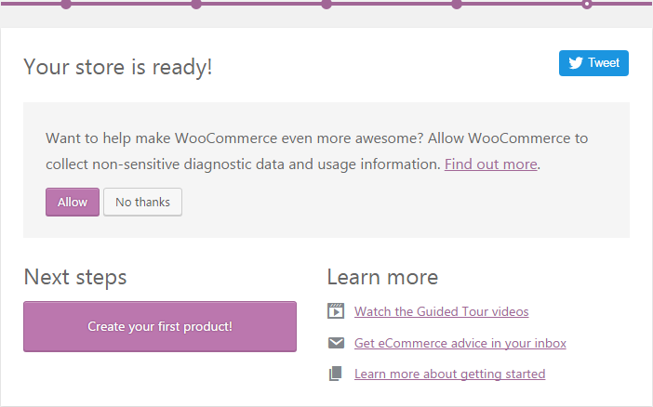

### YITH WooCommerce Wishlist

This plugin will add a new button **[Add to Whishlist]** in our online shop. Install and activate it:

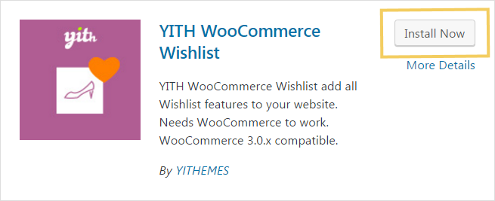

### Anywhere Elementor

Install and configure the **“Anywhere Elementor” plugin**. It will be used later to insert the social sharing icons in the footer area (as sidebar widget, using short code).

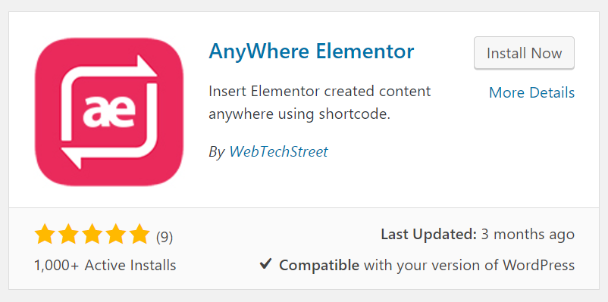

### WP Super Cache

Install and configure the **caching plugin** to improve the site performance:

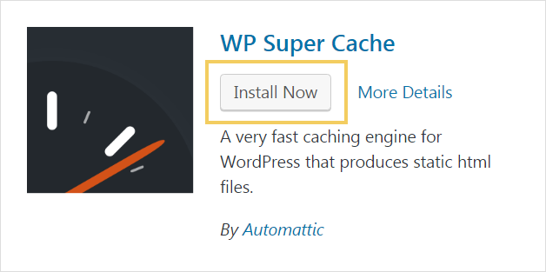

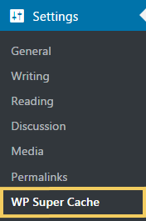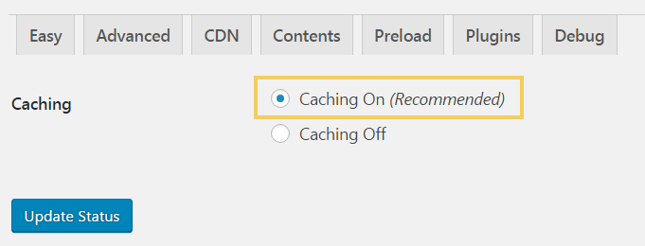

## Configure the Site Settings

Follow the screenshots to setup your **site configuration settings**. First enable SEO-friendly URLs for your posts:

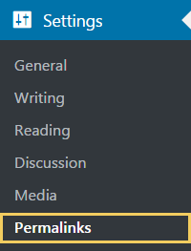 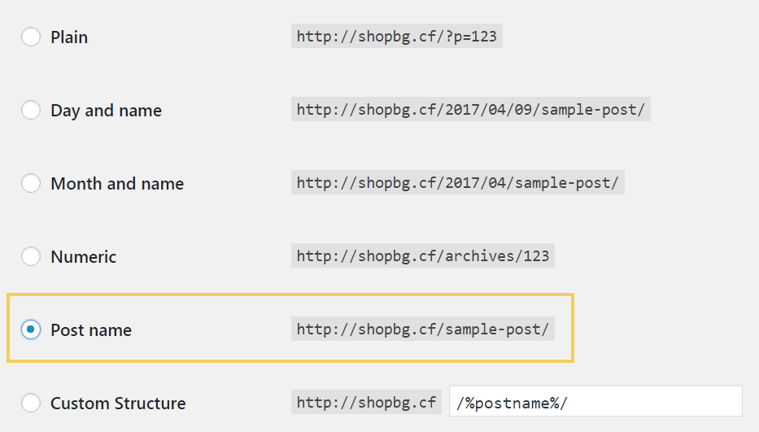

Modify some other **site settings**:

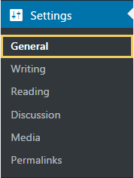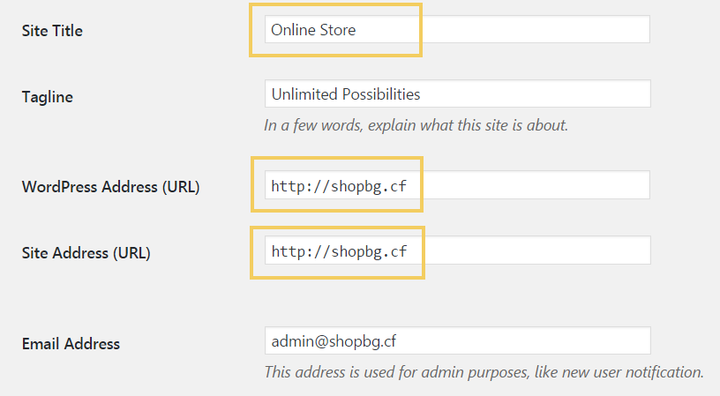

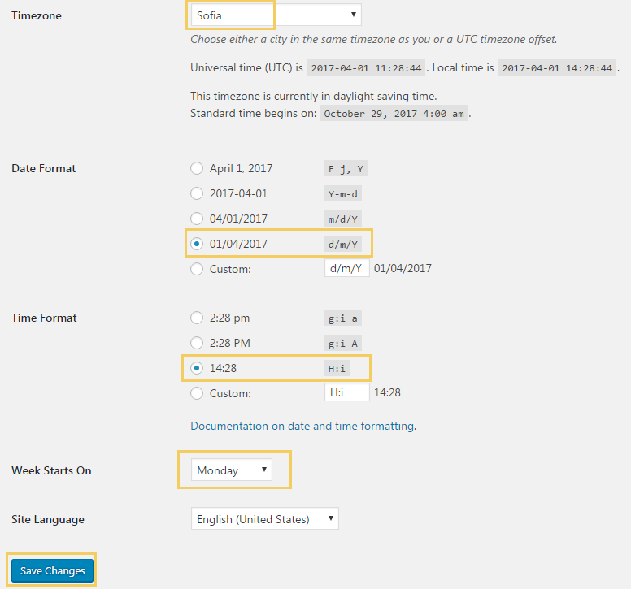

## Upload the Media Files

You are provided with a few **images** for your Web site. **Upload them** in your media library. You may also use your own images.

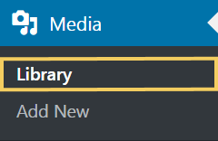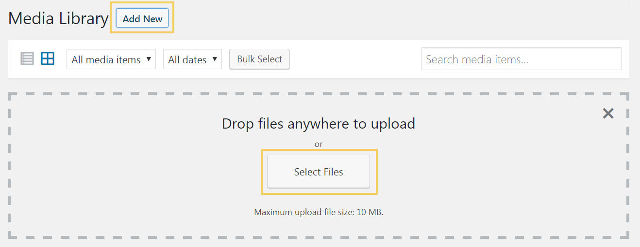

## Create “Home” Page

The term “**home**” or “**home page**” or “**front page**” is used in Web development to refer to the main page of a Web site. It is often used in the navigation menus and other user interface elements of the website to direct users to the main page. By **default**, a WordPress website shows a home page listing your latest posts in reverse order by date.

* Go to your WordPress **Dashboard** -> [**Pages**] -> [**Add New**].
* Title your first page “**Home**”.
* Go to the Page attributes on the right side and select “**Full Width Page**” in the **Template** drop down. This will display this page using the home page template (as front page).
* Click the **[Publish]** button.
* Hide the Home title.

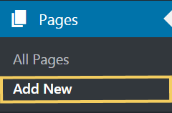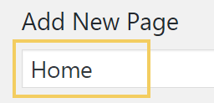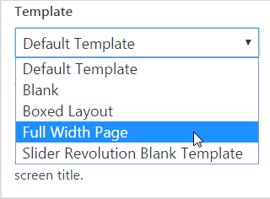

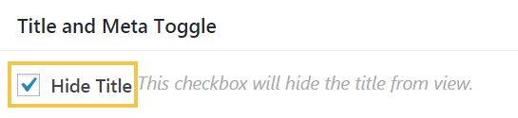

Your "**Home**" page should look like this

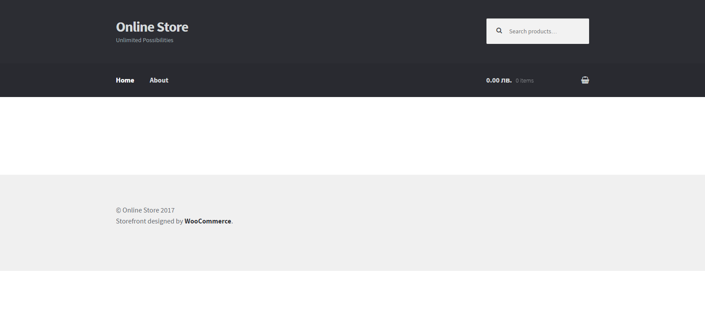

## Create Top Menu, Secondary Menu and Add Pages

The next thing you need to do is create website menus and add create all pages.

* Go to your [**Dashboard**].
* Find the [**Add Pages**] tab.
* Create **About**, **FAQ**, **Home**, **Privacy** **Policy**, [**Terms and Conditions**](http://shopbg.cf/wp-admin/post.php?post=180&action=edit)
* Create **Top Menu** and **Secondary Menu**

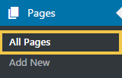 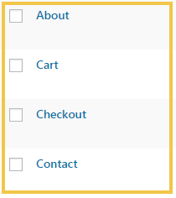 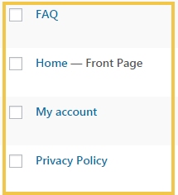 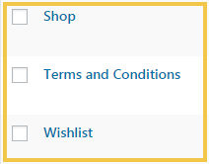

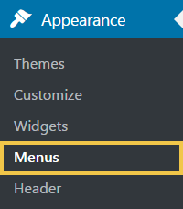 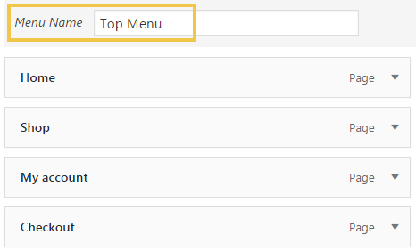 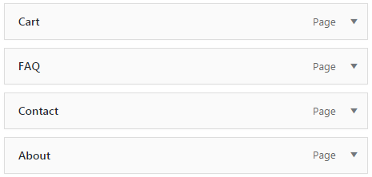

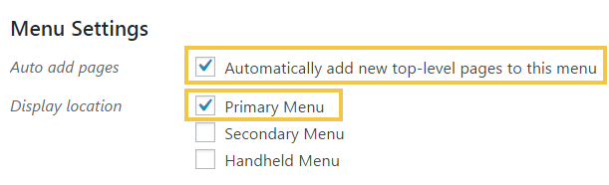

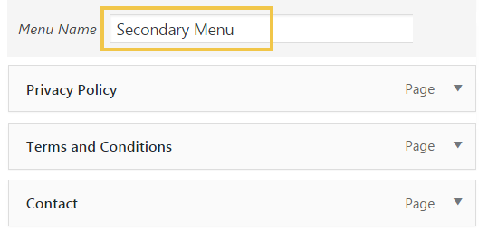 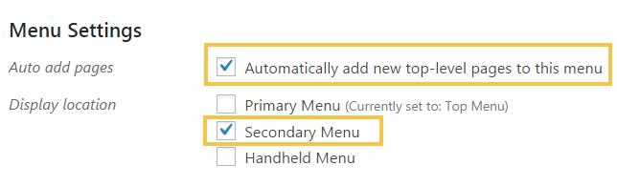

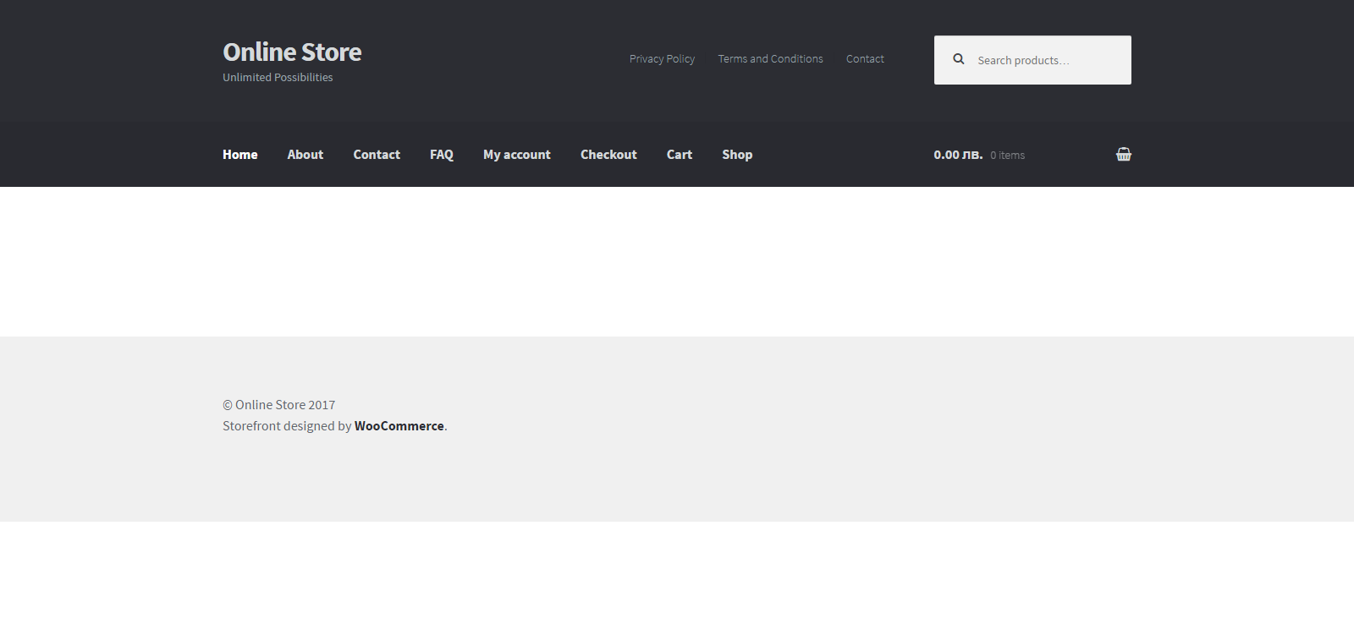

## Customize the "Home" Page

Using the “**Elementor**” page builder, create the Home page:

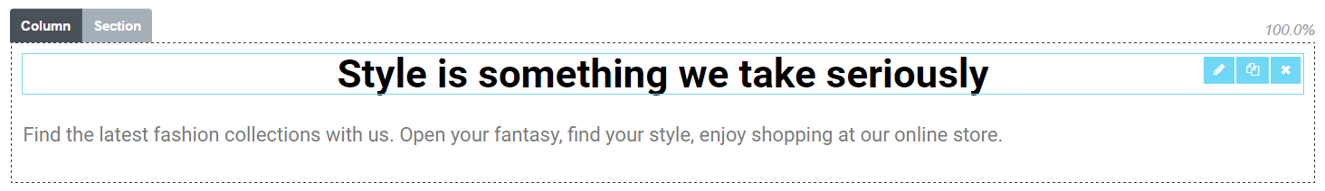

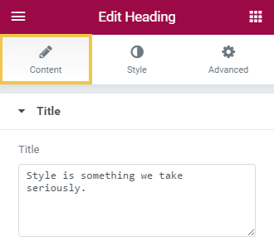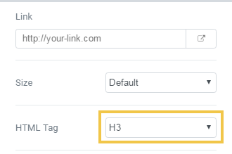

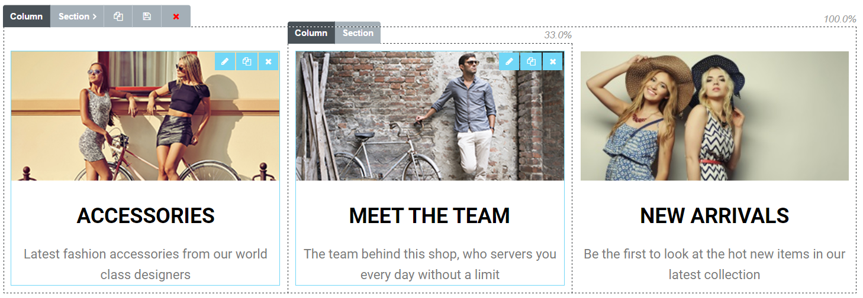

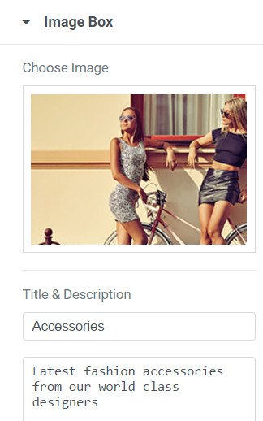 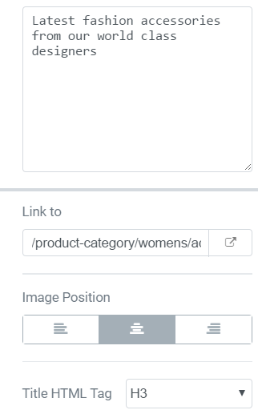

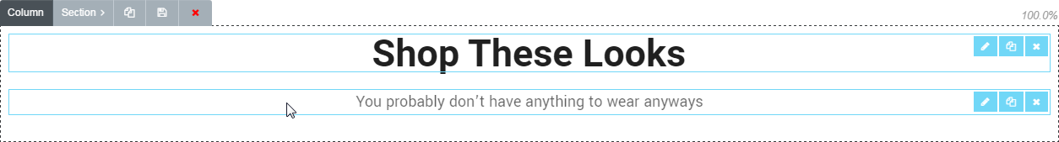

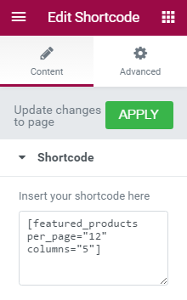 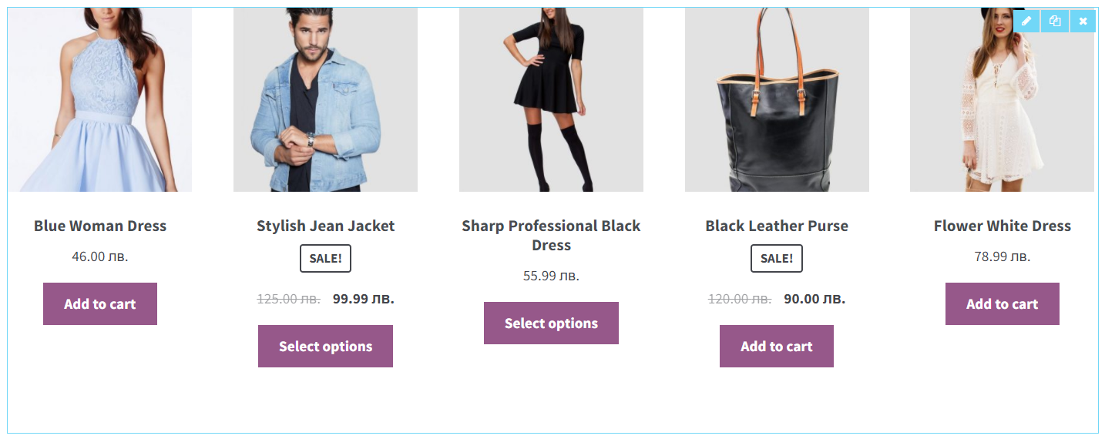

Short code: **[featured_products per_page="12" columns="5"]**



## Create the "Shop" Page

The shopping page is already created by **wooCommerce**. All you need to do is to edit the page slightly:

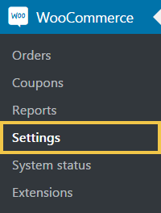 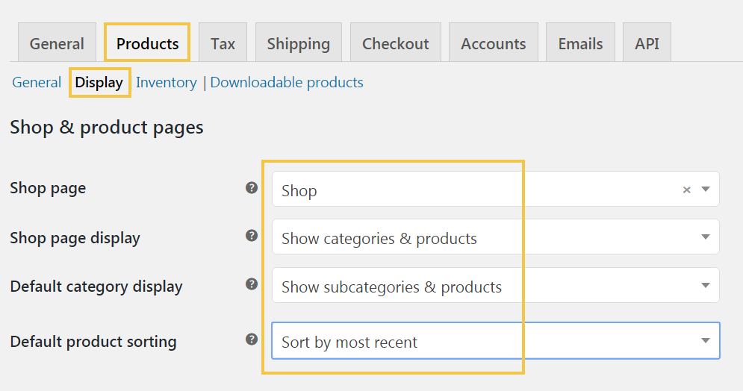

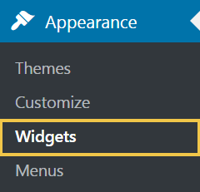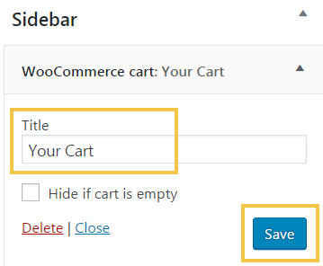

## Add Single Products

This is where you’ll be **adding the products** you’ll be selling on your website. This is probably the most important and time consuming part of building out your e-commerce website.

Go to [**Dashboard**] -> [**Products**] -> [**Add New**]

* Add a **title** and **description** in the main content section (the description you put in will be in the additional information section).
* Add **Product Data** information (this is where you’ll put in the price and SKU and everything else).
* Click on the [**Advanced**] tab and check to **enable reviews** (if you want).
* Add a short description in the “**Product Short Description**” section (this will be next to the main image).
* Add or select **categories** on the right (on the right side).
* Add product **tags** on the right (on the right side).
* Add or select categories on the right (on the right side).
* Add **Featured Image** for the main image.
* Add images into the **Product Gallery** section for additional images to be viewed.
* Click [**Publish**].

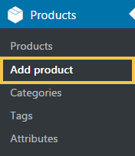 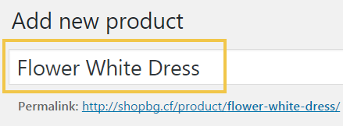

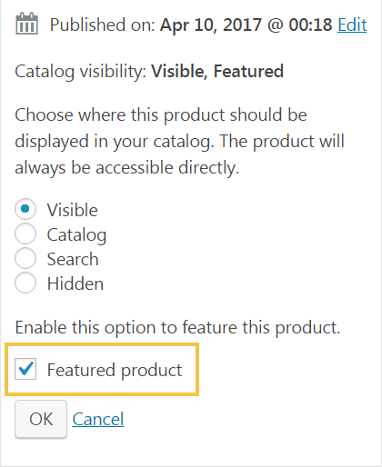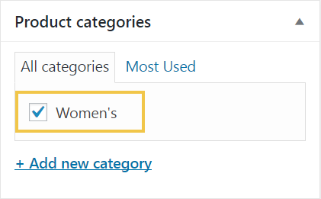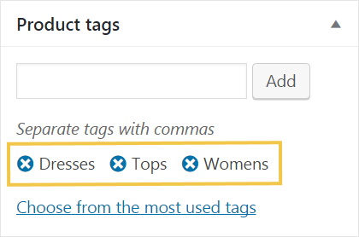

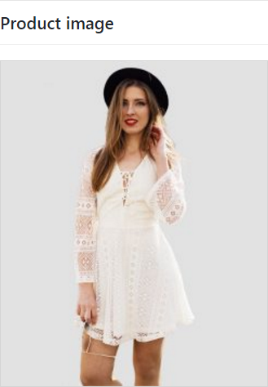 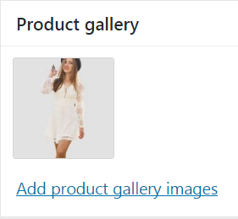

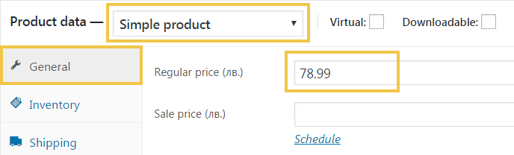

Add another **products**

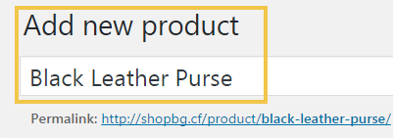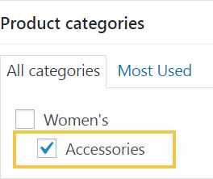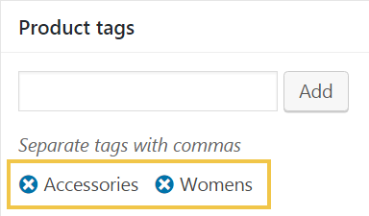

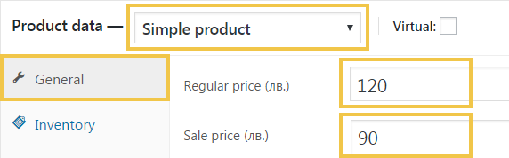

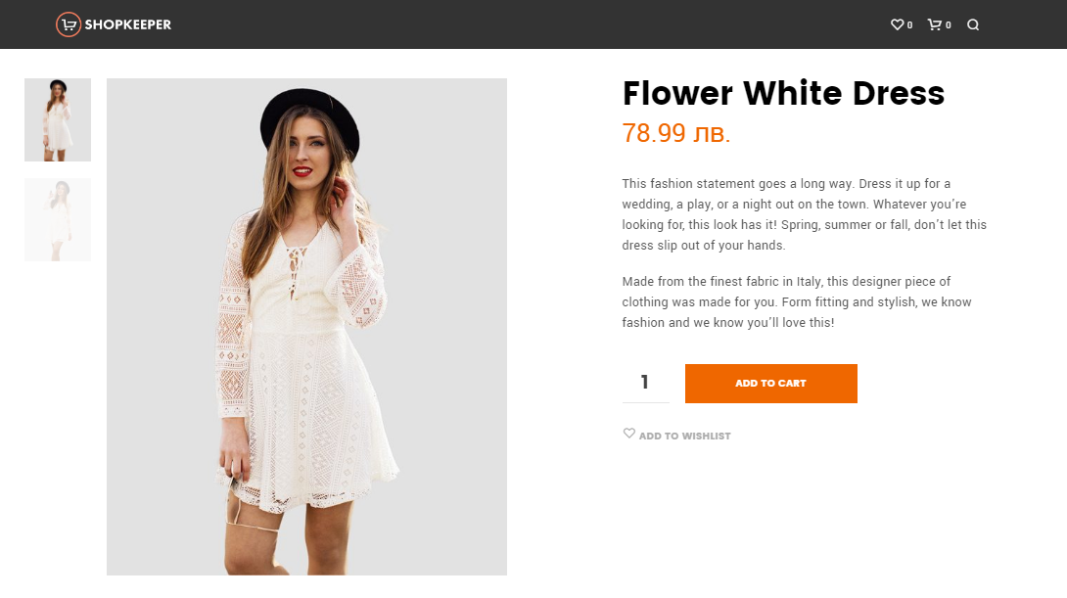

## Variable Products

If you have different sizes or different price points, you can add **variations** to your products with rather than just have one size / price:

* In the [**Product Data**] section -> select [**Variable Product**] -> Add general information.
* Go to the [**Attributes**] section -> Click the blue button that says [**Attributes**].
* Click [**Create Custom Attribute**].
* Create a name for your attribute (size, weight, etc.) 🡪 then in the values section, add your attributes. Instead of using a comma use a "**|**" to separate the attributes (it will automatically add a comma to your list of attributes if you have the “Visible on product page” selected.
* Click on [**Used for Variations**] if you want to allow a customer to select different variables (most likely).
* Click [**Save Attributes**] when done.
* Now go to the [Variations] tab 🡪 in the drop down select [**Create Variations from All Attributes**] 🡪 click [**Go**] .
* Modify and add different prices and other options.

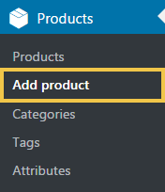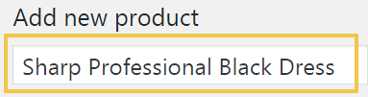

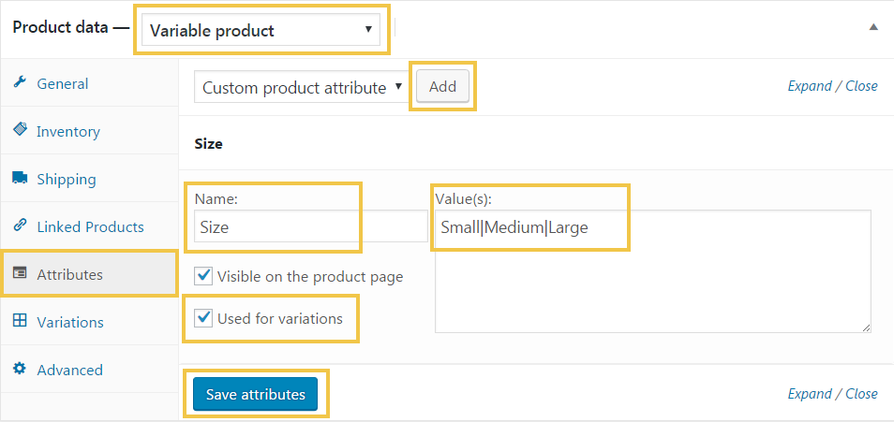

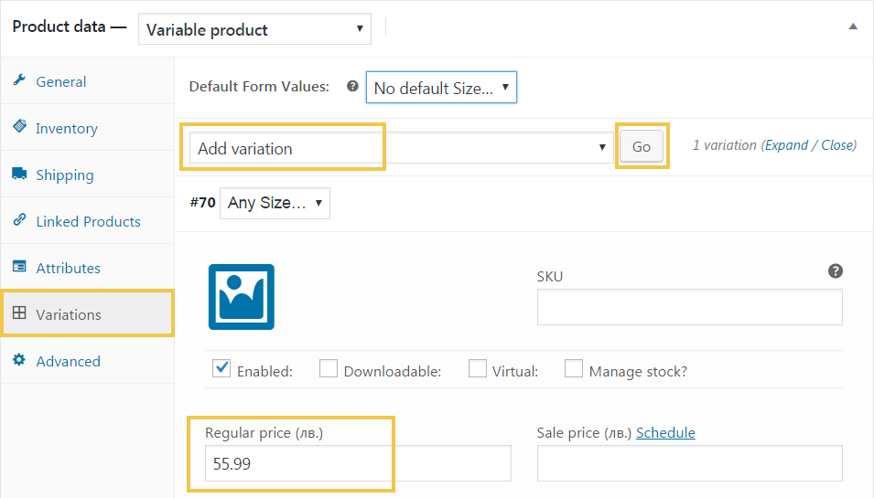

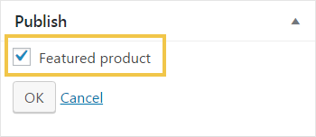

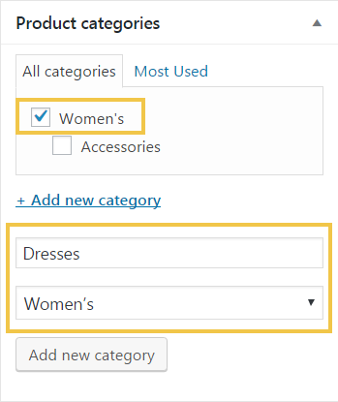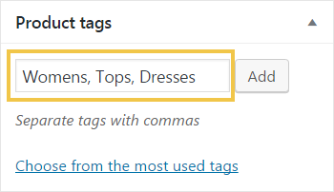

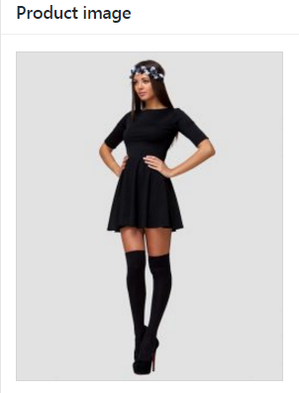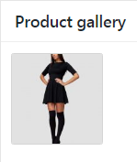

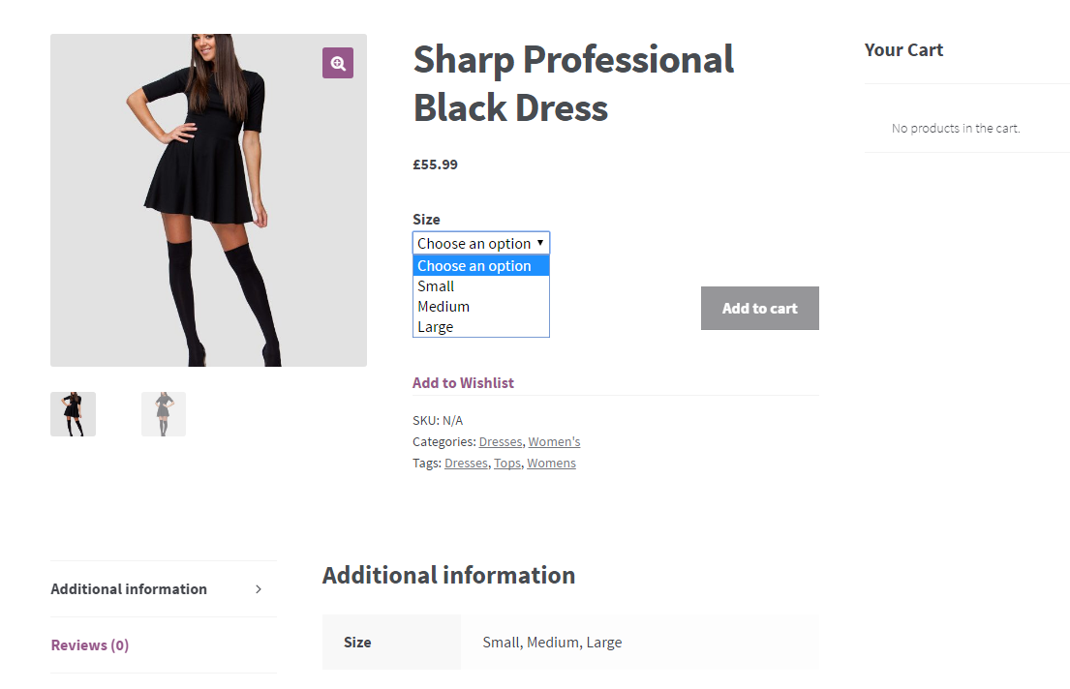

Do exactly the same, but this time add option for color and different product price

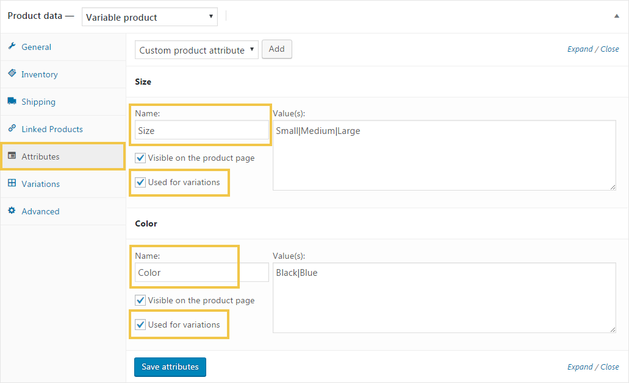

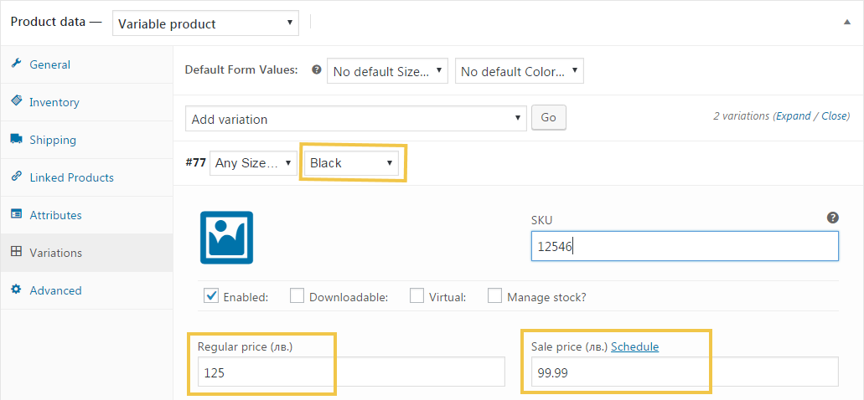

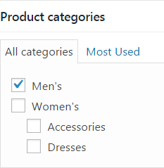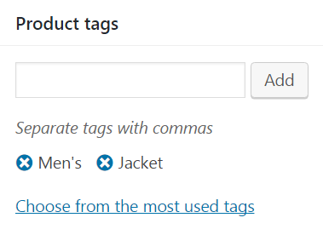

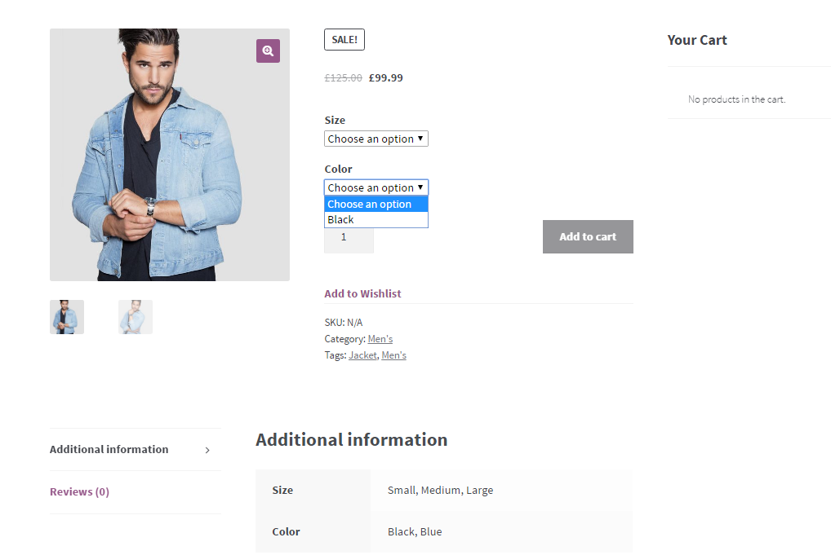

## Add a Few More Products

You need to add some **more products** to your online store. Do it like you added the previous products.

## Create the “About” Page

Using the “**Elementor**” page builder, create the “About” page. Use two sections:

* First section: heading + text.
* Second section: heading + 3 columns, each holding image + text.

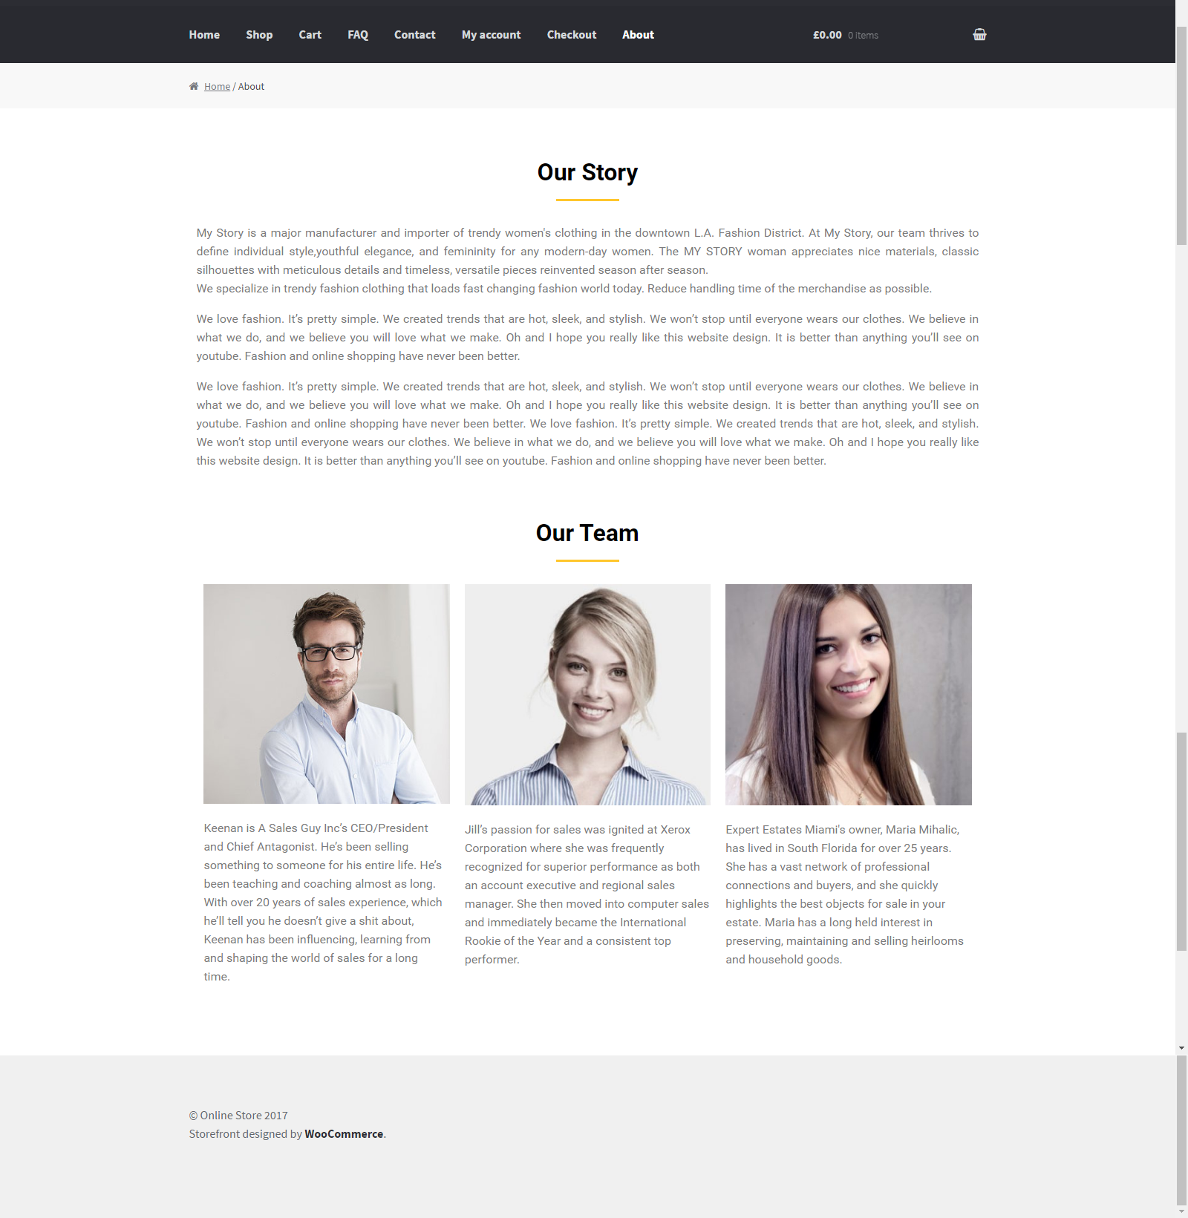

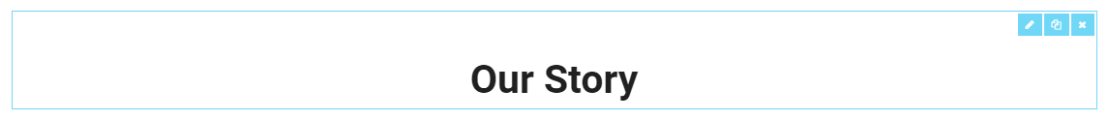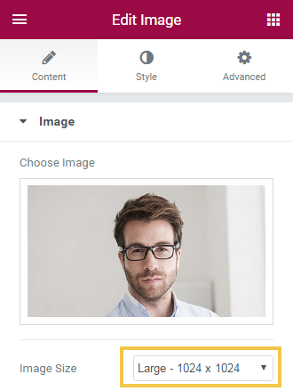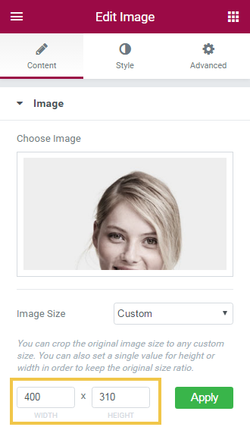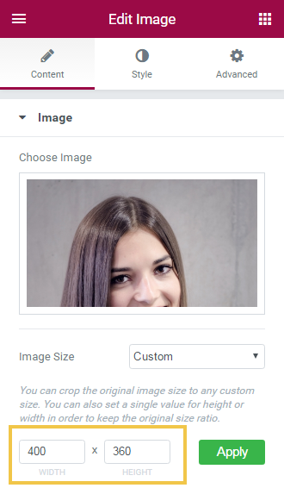



## Create the “FAQ” Page (Frequently Asked Questions)

Using the “**Elementor**” page builder, create the “FAQ” page. Use two sections:

* First section: heading + 2 columns, each holding headings + texts.
* Second section: heading + button. Use full-width layout.







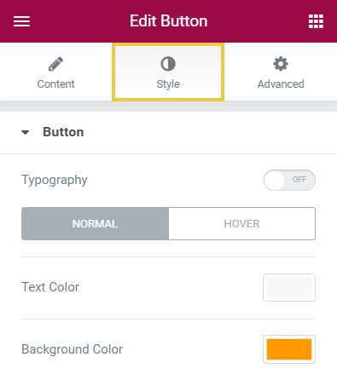 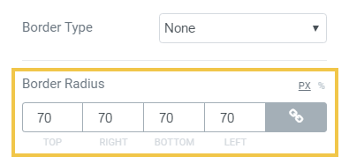

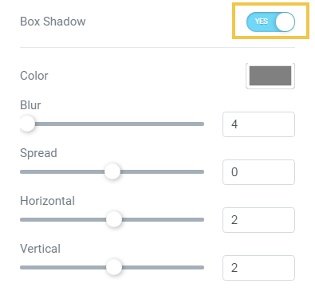

* Divider-color: #ffc72f
* Header-color: #ff6600
* Background-color: #dd4040
* Button-color: #ff9900
* Button-color on hover: #8e2115

## Create the “Contact Us” Page

Using the “**Elementor**” page builder, create the “Contact Us” page. Use **heading** + **text** + **map**. Use the “**Icon List**” widget for the phone, email and street address.



## Create the Site Footer

Now create the **site footer**:

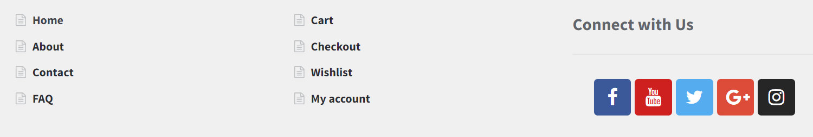

The site footer will hold **3 footer columns** (sidebar areas):

* **Custom menu**, holding links to [Home], [About], [Contact], and [FAQ] pages.
* **Custom menu**, holding links to [Cart], [Checkout], [Wishlist] and [My Account] pages.
* Text holding an **Elementor page** (the social icons), inserted through the “Anywhere Elementor” plugin by a shortcode like this: **[INSERT_ELEMENTOR id="114"]**

This is how to **create the social icons**:

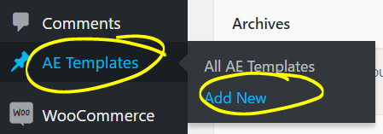

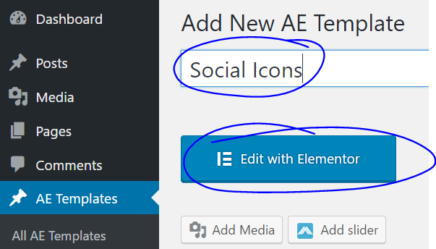

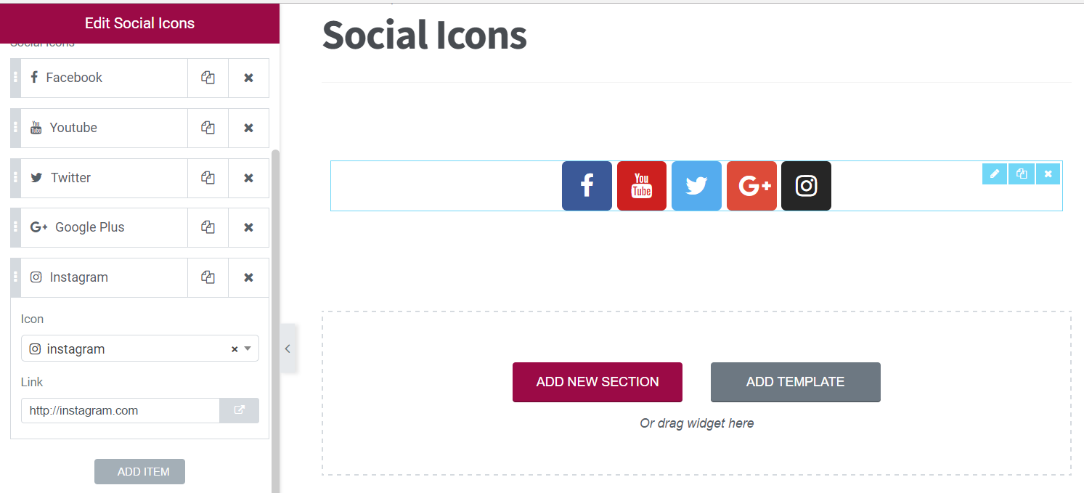

This is how to create the **footer menus** (before inserting them as widgets):

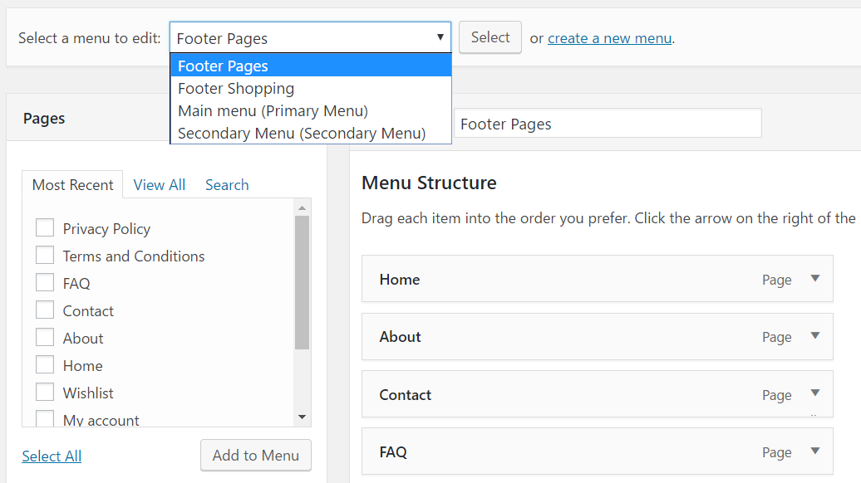

This is how the **footer widget areas** should look like:

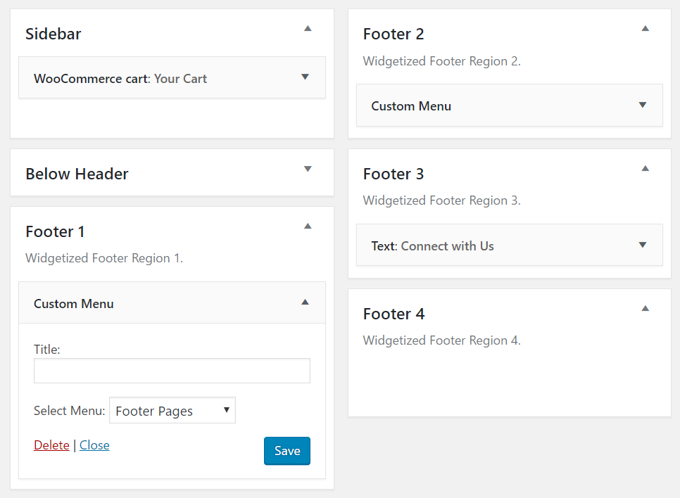

## Add a Slider at the Home Page

First, **create the slider** (using the Smart Slider 3 plugin):

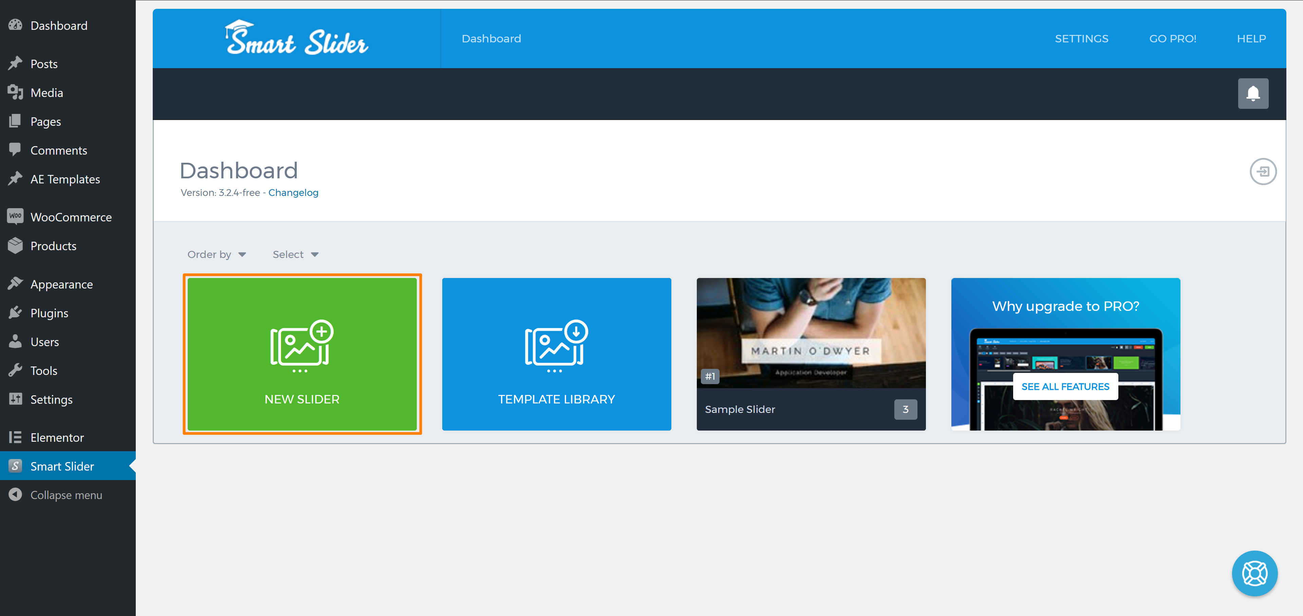

Next, **insert the slider** at the top of the Home page, using the Elementor page editor (use the shortcode widget). Use Font – Pacifico, 76px, left aligned for text on first slide like as shown:



## Add Live Chat (Optionally)

Create and account at <https://www.tidiochat.com> (it's free). Add the “**Tidio Live Chat**” plugin:

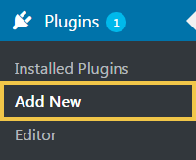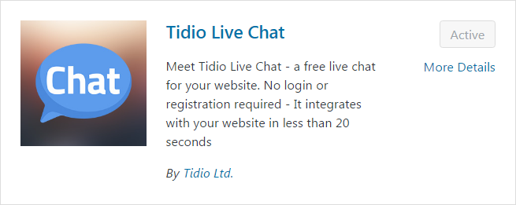

Insert the Tidio script in your “header.php”.

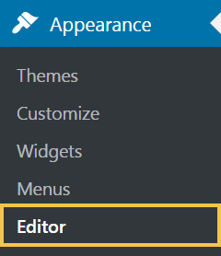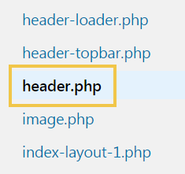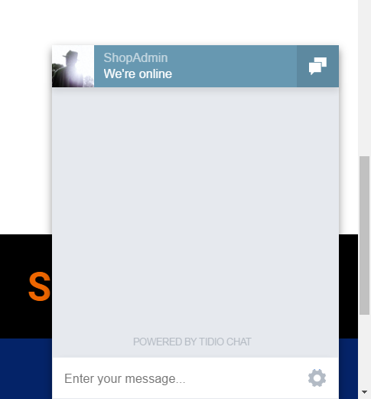

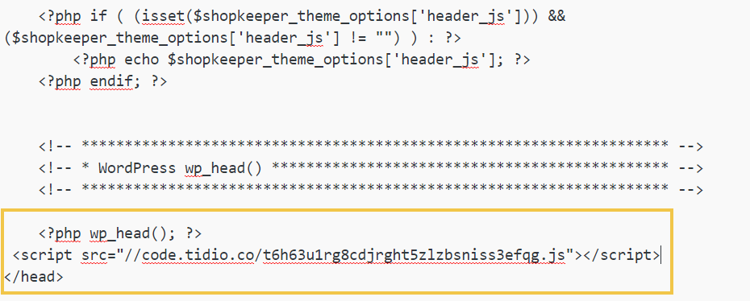

# What to Submit?

To ensure you have completed this homework, submit it at the course web site.

Create a **text file** or **Word document** or **PDF** (e.g. trifon-wordpress-homework.docx) holding your assets.

* Put in the file **screenshots** of all your site pages.
* Insert the screenshots in your homework document or upload them somewhere and provide links, e.g. <http://imgur.com/a/Z3SbB>.

Submit your text file (or document) as **homework** at the course Web site.